Mud Slide
Bottom-Coating Instructions

Background:
Mud Slide bottom coating is formulated specifically for air boats to provide an abrasion-resistant, low-friction surface for smooth operation over mixed-aqueous surfaces typical of air boat operation. The resins selected for this product are superior to typical laminating resin and provide for minimum porosity and maximum resistance to moisture and contact wear. It is comprised of this blend of high quality resins along with dry lubricants to minimize surface friction. Preparation of this product is similar to that of fiberglass resins in that a catalyst must be added to cause the resin blend to cure.

Precautions:
Please review the MSDS before using this product. The resin blend itself is a flammable liquid. Use with adequate ventilation and keep away from open flame, sparks—no smoking. The catalyst (MEKP, Methyl Ethyl Ketone Peroxide) is a strong oxidizer and is extremely irritating to skin and mucous membranes. Avoid breathing vapors and avoid skin contact.

Coverage:
Based on a suggested sprayed coating thickness of about 10 mils (.010”), a quart of sprayed Mud Slide will cover about 50 square feet.

Surface Preparation:
Mud Slide Bottom Coating can be applied over a number of different substrates including aluminum, fiberglass, and even previously painted or coated surfaces. Each case requires slightly different preparation methods.

Option 1: Gel-coat/Fiberglass hulls
- Gel coat surface can be abraded using a 120 grit sanding disk with a flexible back. You simply want to remove the gloss, not the gel coating. For the new coating to stick properly, all glossiness must be removed.
- This can be checked during the cleaning step with soapy water. After rinsing, the surface should be uniformly wet with no areas where the water beads up.
- Tape and cover parts NOT to be coated such as the sides above the chines.
- Immediately prior to coating, wipe surfaces to be coated with acetone.

Option 2: Fiberglass Hulls with previously applied bottom coatings
- Remember that while the Mud Slide resin is very tenacious and sticks effectively to a range of surfaces, its ability to remain a part of the hull is only as strong as the prior coating that is allowed to remain. Whether to remove the previous coating will be a judgment call on your part. The other risk of retaining a prior coating is incompatibility. The resin in Mud Slide can attack some paints resulting in wrinkling or peeling. To be safe, our recommendation is that a previously-applied bottom paint be removed completely right down to the gel coat.
- Then the gel coat surface can be abraded using a 120 grit sanding disk with a flexible back as in Option 1. Again, as in Option 1, you simply want to remove the gloss, not the gel coating. For the new coating to stick properly, all glossiness must be removed.
- This can be checked during the cleaning step with soapy water. After rinsing, the surface should be uniformly wet with no areas that the water beads up.
- Tape and cover parts NOT to be coated such as the sides above the chines.
- Immediately prior to coating wipe surfaces to be coated with acetone.

Option 3: Aluminum Hulls/Bare Aluminum
- Organic coatings do not stick well to raw aluminum. To achieve a superior bond of Mud Slide coatings to an aluminum surface, an adhesion promoter must first be used.
- The most popular adhesion promoter for aluminum alloys is known as Alodine which is a conversion coating. It is simple to apply and provides a fantastic tooth for paints, resins, and adhesives to adhere to. Additionally, most formulations contain chromium which provides corrosion protection in the developed layer. For maximum adhesion and corrosion protection, we recommend a chromium-based conversion coating such as Alodine 1201.

Mixing & Application of Mud Slide Resin:
- Agitate Mud Slide resin in its original container with a mixer for about 2 minutes. The use of a mixer on the end of an electric drill is the most common method for this. This mixing step is to assure the dry lubricant that typically settles to the bottom of the container is suspended and evenly distributed throughout the resin.

- Pour out the desired amount of resin you are going to use into an appropriately sized plastic mixing cup or bucket.

- Based on the volume of resin to be used and the ambient temperature, determine the amount of catalyst needed.

The base mix ratio of catalyst for 1-quart of resin is 2% which translates into about 1/4 of a fluid ounce. This is based on a shop temperature of between 75° and 80°F where this ratio will provide you a pot life of about 15-20 minutes. At warmer temperatures, slightly less catalyst will be required to prevent the mix from gelling before it can be applied. For example, at 90°F about half the catalyst will be required.

- Use the measuring cup provided and measure out the appropriate amount of catalyst.

- When you have assured your surface is prepared and ready for coating, pour the catalyst into the resin and continue mixing for at least an additional minute.

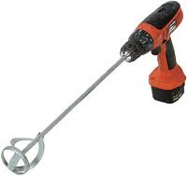

Applying Mud Slide:
- The mixed and catalyzed resin can now be applied to the surface. Alternatively, it can be poured into a Gel Cup Gun (e.g. an ES G-100) or into an HVLP spray gun with a large orifice (as used for spraying gel coats) and then sprayed onto the surface.

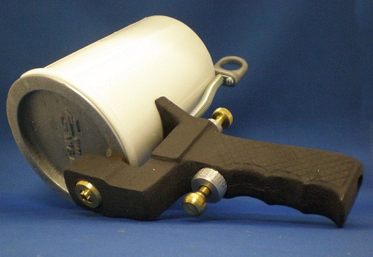

The standard of the industry—the ES G-100 Gel Cup Gun
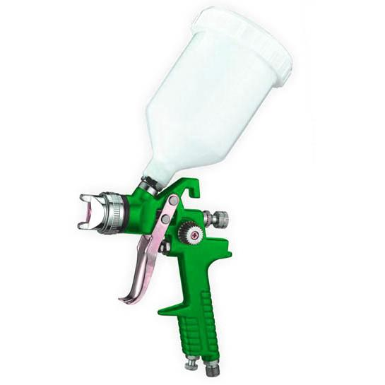
Typical gravity-fed HVLP spray gun

Notes:
Do not spray in the rain or when temperature is less than 70ºF. Always wear protective safety apparel when mixing and applying this product. Mix and spray in well-ventilated area, preferably outdoors. Avoid contact with skin and eyes.

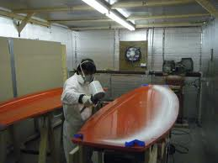
A gel cup gun being used to spray gel coat onto a sail board.

- Typical coating thickness is .010 to .020”.
- If applying by brush, do not over-brush. Once the mixture is applied to the surface it becomes gel-like. Further brushing only tears the surface.
- Surface will generally cure to the touch in about an hour and is ready for use overnight.
- Once cured, no further finishing is required although slight bumps, dust or other imperfections can easily be removed using 600 grit wet-or-dry sandpaper with water as a lubricant.
- The resulting coating will be as tough as the original gel-coat surface of a fiberglass hull but with enhanced lubricity and water repellency.

